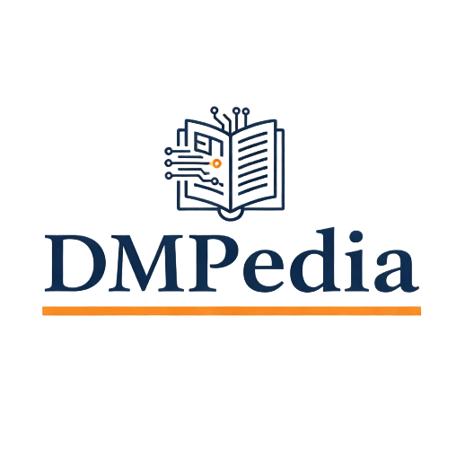

DMPedia Proceedings Proposal Form

The following questions are designed to help us get a clear picture of your proposal and to provide us with information about the readership, which will enable us to develop an effective marketing and promotion strategy. Please complete the form as precisely as you can.

Full or working title of the Conference:

Subtitle:

Name and address of each editor as they should appear on the conference proceeding cover (i.e. only author(s) or volume editor(s), not the series editors or contributing authors). Please underline surnames.

Name + Academic Title(s) | Address (workplace) | Email

Please attach a curriculum vitae (including relevant publications) of each editor.

- When do you anticipate being able to submit the first complete draft? _____

CONFERENCE PLAN

- Please indicate a conference webpage address and/or a Call for papers.
Webpage address (If any)

Call for Paper (Link or Attached PDF)

- Please indicate WHERE and WHEN the conference will take place

- Please list the names of Conference Organizers and Boards

- Is any society involved in the organization of this conference?

- Please indicate the conference history (is this the first edition of the conference? If not, please indicate the previous edition of this conference, the number of participants attending it, the conference webpages and, if available, please cite previous proceedings publications related to those

- How many participants do you expect?

- Proceedings financed only by attendance fees and not by direct paper publication payment will be considered for publication. Do you agree with and/or have any comments on that?

- We expect that at least one of the authors for each article accepted in the book will attend the conference. If the author of an accepted papers does not register to the conference, his/her paper should not be included in the book. Do you agree with and/or have any comments on that?

REVIEW PLAN

- Please describe the review process as detailed as possible.

- Please specify the detailed review time plan (submission deadline, notification of acceptance, submission deadline for revised papers)

- Please list the names, affiliation (and webpage, if available) of the reviewers who will be effectively involved in the review process, who have already given their availability to review the papers.

- Please indicate the (expected) acceptance rate

SPECIAL INSTRUCTIONS

- Do you use any plagiarism AI Detection and SciGen detection system?

Please be aware that a few people may try to do unprofessional and/or unethical things, e.g. submit fake (automatically generated) papers, submit two or more very similar papers (self-plagiarism, dual publication), present the work of others as it were their own and without proper acknowledgement, use falsified/fabricated data. A careful review process and a system to detect plagiarism should enable you to detect those attempts.

ABOUT YOUR CONFERENCE PROCEEDINGS

If you have not already provided us with a brief synopsis (approx. 3500 characters), which can also be used as the back cover text to the reader and a provisional table of contents, please do so when you return this form. Additionally, please provide us with a list of those features that set your conference proceedings apart from others in the field. Please list them in order of importance. If this is not the first edition of your conference proceedings, please state the improvements over the last edition.

Please provide us with a preliminary description of the structure of your conference (e.g. Tracks). We usually require a topical organisation in different parts, e.g. according to the main conference topics.

Keywords/Conference Topics
- Please list any keywords associated with your conference theme.

MARKET
- Names and Addresses of persons you know of who are willing to help promote and sell the conference proceedings

Many thanks for taking the time to complete this questionnaire. Your detailed responses will be very helpful in our assessment of the potential market for your proposal and enable us to decide on publication much sooner.

Editor
Digital Manuscriptpedia
contact@digitalmanuscriptpedia.com

